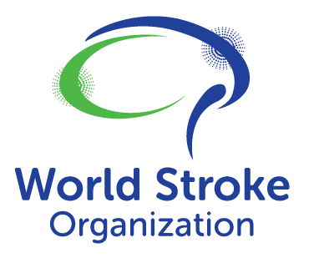
Statement to the 158th Session of the WHO Executive Board

We welcome the Resolution on Reducing the Burden of Stroke as a key intervention to accelerate progress towards global health and development goals.

Stroke causes 7 million deaths and 145 million DALYs annually. By 2050 we face sharp projected increases in stroke mortality and morbidity, which will disproportionately affect LMICs, where access to even the most basic stroke care is limited. Advances in stroke prevention and treatment offer unprecedented and cost-effective opportunities to transform stroke care, and to address growing global inequities in access and patient outcomes.

We commend Member States for their commitment to a comprehensive and co-ordinated stroke response, as part of their NCD strategic response.

WSO urges the Executive Committee to support this Resolution.

