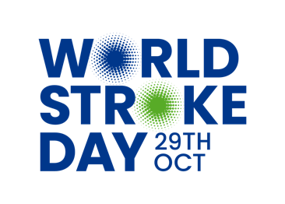 | [Insert partner logo]

PRESS RELEASE
For immediate release 00:01 28th October

[Insert city/landmark name] Lights Up Blue for World Stroke Day

{Insert landmark name is lit blue today to draw public attention to one of the world’s leading causes of death and disability and the importance of knowing the signs of stroke. [Insert location] is part of a global chain of buildings and landmarks participating in the World Stroke Day campaign.

Globally, 1 in 4 of us will have a stroke in our lifetime and every year 6.5 million people will die as a result. Stroke happens when the blood supply to a part of the brain is interrupted either by a clot or by a bleed which causes surrounding brain tissue to die. Damage to the brain means that stroke survivors can be left with disabilities and impairments that affect how they move, speak, think, and feel. ‘Knowing the signs of stroke is critical. Minutes can save lives, speech, mobility, and independence. If you spot –face drooping, weak arm, and speech difficulties dial [insert local emergency medical services number] immediately’ Said
[Insert details of local spokesperson] ‘Everyone stands to benefit from better community awareness of stroke. This is why we are working with the World Stroke Organization to deliver their Minutes Save Lives campaign and why we are proud to be part of the World Stroke Day Global Light Up.

You can find out more about stroke, test your stroke spotting speed and get involved in the World Stroke Day Minutes Save Lives selfie campaign at www.worldstrokecampaign.org #Precioustime.

For local information about local stroke awareness campaigns and services to support stroke survivors and caregivers please contact [insert local contact details].

ENDS

