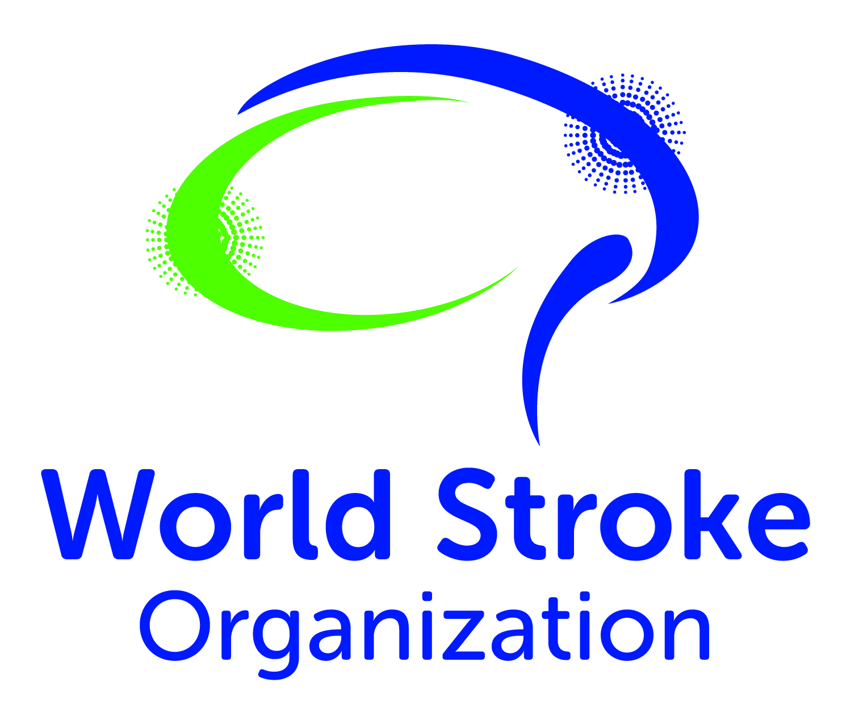

STROKE
Together We can Cut Stroke in Half
STROKE

July 2019

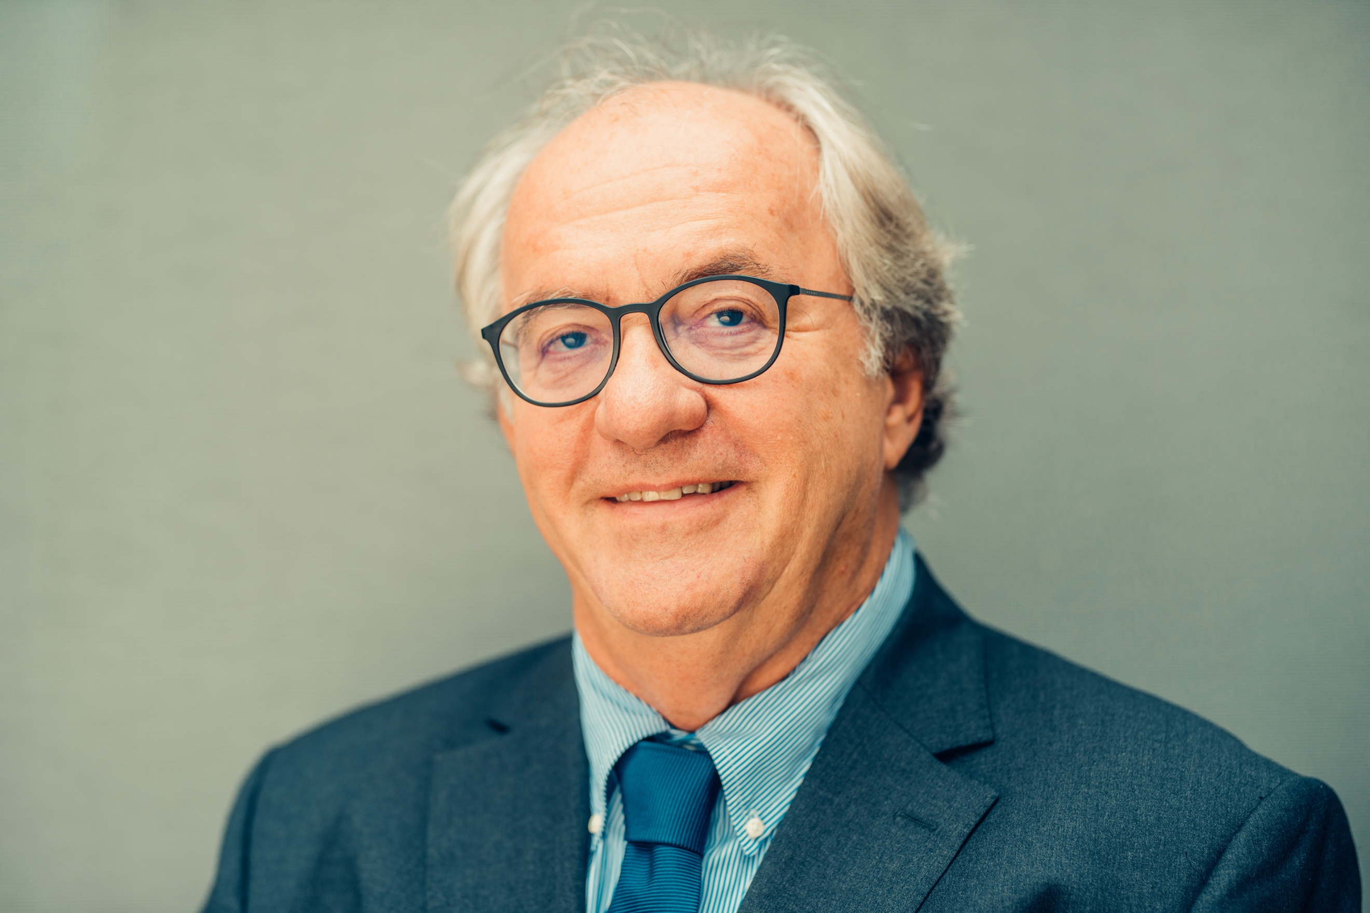 | Right now, we have the opportunity to save millions of lives and to prevent trauma, disability and poverty for millions more. Why wouldn’t we grasp that opportunity with both hands?  Prof Michael Brainin, WSO President

Stroke Facts

- 1 in 4 people over the age of 25 will experience a stroke in their lifetime
- 80% of people who have a stroke live in the world’s poorest countries
- 90% of strokes are associated with 10 modifiable risk factors

Evan’s story
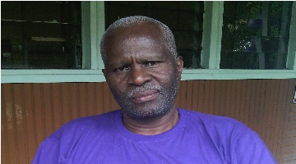

I was on my way to work when I had my stroke, I live in a village in Nigeria a long way from any health facilities. The medical facility I was eventually taken to was ill-equipped, doctors were unable to immediately diagnose the problem, or offer any stroke-specialist emergency care. The problem was only detected after three days, by which time my situation had worsened, and I was transferred to Nairobi for further treatment.
Diagnosis took a very long time. My treatment will be life-long - I have to take medicine on a daily basis. I have lost my job as a pharmacist because my employer could not understand my problem and my impaired movement and speech means I can’t meet the requirements of the role. My rehabilitation was prohibitively expensive which, combined with my loss of employment, has led to abject poverty. I now rely on family and friends to take care of me, which of course they can’t always do because they have their own responsibilities.
I know I am very lucky to be alive, but I worry all the time that I may never manage to get my full function back or be able to provide for my family. My stroke has caused the people around me such economic and emotional anxiety.

Preventing stroke

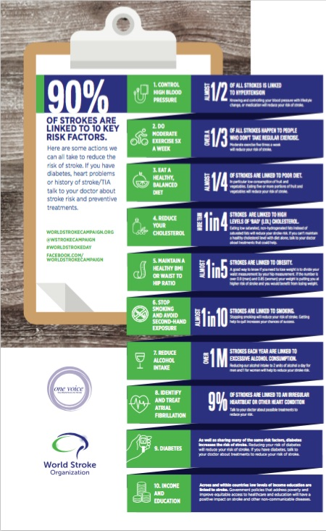

The World Stroke Organization leads a global stroke collaboration that aims to identify, implement and evaluate the impact of integrated pharmacological, health systems and technological interventions that, based on current evidence have the potential to cut the burden of stroke in LMICs by 50%

This Cut Stroke in Half collaboration network has developed a clear strategy, backed by evidence. The strategic response includes:

- Access to medicines
- Community Health Worker Capacity Building
- Mobile motivational technologies

Community Health Worker Capacity Building
According to WHO almost half of all UN member states have fewer than one physician per 1000 population. There are 1.3 million community health workers (CHWs) who, despite limited education and training have demonstrated that they can be mobilised as part of an integrated health system response and reduce mortality and morbidity. (Perry, Zulliger and Rogers, Annual Review of Public Health, 2014).

Task- shifting to effectively trained Community Health Workers to support prevention of stroke through effective diagnosis and management of risk factors such as hypertension, diabetes, obesity, high cholesterol has the potential to impact significantly on stroke incidence and contributing to reduction of a number of other NCDs including dementia, diabetes, heart disease and cancer.

In partnership with our local members, WSO aims to develop the capacity of CHWs within health systems through implementation and evaluation of demonstration projects providing interventions with medium risk individuals in five countries.

- Brazil
- India
- Nigeria
- Philippines
- Vietnam

Facilitated by a WSO and the global program coordinator the Cut Stroke in Half CHW program would deliver:

- 2 global national coordinators’ workshops
- 1 e-learning program and online resource centre for stroke CHW trainers
- Annual global project monitoring and evaluation reports
- Five-year impact measurement report

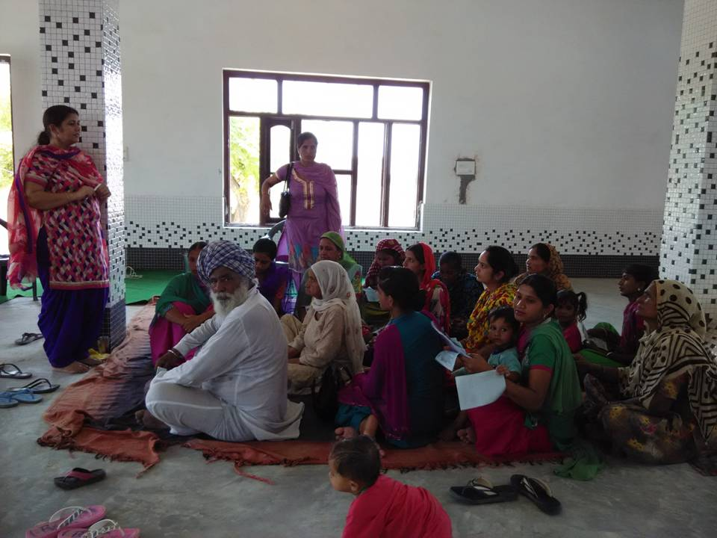
National programs would deliver

- 1 stroke prevention system workshop
- 4 CHW training workshops
- 1 stroke focused train the trainer program
- 200 Community Health Worker training programme participants
- 200,000 medium risk prevention program participants
- Effective prescribing and access to medicines systems
- Quarterly national monitoring and evaluation reports
- Patient education materials

